

TRIBHUVAN UNIVERSITY
INSTITUTE OF ENGINEERING
THAPATHALI CAMPUS

A Project Proposal
On
REAL-TIME DIRECTIONAL ANTENNA ALIGNMENT USING REINFORCEMENT LEARNING AND RSSI FEEDBACK

Submitted By:
Atul Tiwari (THA079BEI006)
Bibek Joshi (THA079BEI007)
Inisha Maharjan (THA079BEI012)
Suprim Koirala (THA079BEI043)

Submitted To:
Department of Electronics and Computer Engineering
Thapathali Campus
Kathmandu, Nepal

December 2025

ACKNOWLEDGEMENT
We would like to express our sincere gratitude to the Department of Electronics and Computer Engineering, Thapathali Campus, for providing us with the opportunity to carry out this project. We are especially thankful to Er. Saroj Shakya for his continuous guidance, constructive suggestions, and encouragement during the formulation of this project proposal. His insights have been invaluable in refining the problem statement, methodology, and overall direction of the work. We also acknowledge the support of the faculty members of the department for their helpful discussions and academic guidance during the proposal preparation phase.

Atul Tiwari (THA079BEI006)
Bibek Joshi (THA079BEI007)
Inisha Maharjan (THA079BEI012)
Suprim Koirala (THA079BEI043)

ABSTRACT
Accurate alignment of directional antennas is essential for maintaining reliable wireless communication links, particularly in low-cost and resource-constrained systems where phased arrays and complex beamforming hardware are impractical. This project presents the design and implementation of an autonomous antenna alignment system that employs reinforcement learning to optimize the orientation of a mechanically steerable directional antenna using real-time Received Signal Strength Indicator (RSSI) feedback. The proposed system consists of a transmitter and an intelligent receiver node equipped with an ESP32 microcontroller, a high-gain 2.4 GHz directional antenna, and a stepper motor for precise angular control. A lightweight tabular Q-learning RL algorithm runs directly on the embedded platform, enabling online learning and continuous adaptation without reliance on prior training data. System performance is evaluated against conventional baseline approaches, including fixed-orientation operation, exhaustive angular scanning, and RSSI-based hill-climbing methods. Evaluation results are quantified using formally defined metrics such as convergence time, alignment accuracy, link stability, mechanical efficiency, and robustness to environmental disturbances. Compared to baseline methods, the proposed approach is expected to achieve faster convergence and reduced motor actuation while maintaining stable link quality. This work demonstrates the practical feasibility of embedded reinforcement learning for autonomous antenna alignment in low-cost wireless systems.

Keywords: Directional Antenna Alignment, Reinforcement Learning, RSSI Optimization, Embedded Systems, Adaptive Control, Wireless Communication

Table of Contents
ACKNOWLEDGEMENT i
ABSTRACT ii
List of Figures Vi
List of Tables Vii
List of Abbreviations Viii
1. INTRODUCTION 1
1.1 Background 1
1.2 Motivation 1
1.3 Problem Definition 2
1.4 Objectives 3
1.5 Scope and Application 3
1.5.1 Project Capabilities 3
1.5.2 Project Limitations 3
1.5.3 Project Application 4
2. LITERATURE REVIEW 5
3. REQUIREMENTS ANALYSIS 10
3.1 Hardware Tools 10
3.1.1 ESP32 Devkit Microcontroller 10
3.1.2 Directional Antenna 10
3.1.3 RF Interfacing 11
3.1.4 Motors 11
3.1.5 Stepper Motor Driver Setup 12
3.1.6 Power Supply and Measurement 13
3.2 Software Tools 13
4. METHODOLOGY 15
4.1 System Block Diagram and Architecture 15
4.2 Source and Receiver Configuration 16
4.2.1 Transmitter (Source Node) 16
4.2.2 Receiver (Directional Antenna Node) 17
4.3 Baseline Methods 17
4.3.1 Fixed Antenna Orientation 17
4.3.2 Exhaustive Angular Scanning 17
4.3.3 RSSI-Based Hill-Climbing 18
4.4 Control Flow 18
4.4.1 Received Signal Strength Indicator (RSSI) 18
4.5 Experience Collection and State Preparation for Reinforcement Learning 20
4.5.1 Data Acquisition 20
4.5.2 Experience Logging and Storage 21
4.5.3 State Representation and Feature Preparation 21
4.5.4 Noise Mitigation and Signal Smoothing 21
4.5.5 RL Experience Tuple Structure 21
4.6 Reinforcement Learning Model Design 22
4.6.1 Reinforcement Learning (RL) 22
4.6.2 Model Design 23
4.6.3 RL Algorithm Selection 23
4.6.4 State Space 24
4.6.5 Action Space 25
4.6.6 Reward Function Design 25
4.6.7 Learning and Exploration Strategy 26
4.6.8 Online Training and Real-Time Operation 27
4.7 Experimental Setup and Evaluation 28
4.7.1 Experimental Environment 28
4.7.2 Evaluation Metrics 28
4.7.3 Experimental Protocol for Method Comparison 30
4.7.4 Statistical Analysis 30
5. EXPECTED OUTCOMES 31
5.1 Functional Autonomous Alignment Prototype 31
5.2 Improved Alignment Performance Compared to Baseline Methods 31
5.3 Feasibility of RL on Resource Constrained Hardware 31
5.4 Quantitative Performance Evaluation and Analysis 31
5.5 Validated, Low-Cost, and Replicable Design 31
6. PROJECT SCHEDULE 33
6.1 GANTT CHART 33
7. BUDGET ESTIMATION 34
8. FEASIBILITY ANALYSIS 35
8.1 Technical Feasibility 35
8.2 Computational Feasibility 35
8.3 Economic Feasibility 35
8.4 Time Feasibility 36
8.5 Operational Feasibility 36
8.6 Academic Feasibility 36
References 37

List of Figures
Figure 3-1: ESP32 Development Board Front and Back View 10
Figure 3-2: High Gain 2.4 GHz Directional Antenna (PCB Panel Type) 11
Figure 3-3: (a) NEMA 17 Stepper Motor (b) Motor Mechanical Layout 12
Figure 3-4: A4988 Stepper motor driver module and its pinout diagram 12

Figure 4-1: System Block Diagram 15
Figure 4-2: Logical Control Flow of Antenna Alignment 19
Figure 4-3: RL Experience Collection and State Preparation Pipeline 20
Figure 4-4: Basic Reinforcement Learning Model 23

Figure 6-1: Project Predicted Timeline 33

List of Tables
Table 1: Summary Table of Literature Review 9
Table 2: Component Power Usage 13
Table 3: Approximate Budget Estimation 34

List of Abbreviations
5G | Fifth Generation Mobile Network
AI | Artificial Intelligence
BF | Beamforming
CNN | Convolutional Neural Network
DQN | Deep Q-Network
ESP32 | Espressif 32-bit Microcontroller
GPS | Global Positioning System
GHz | Gigahertz
ISM | Industrial, Scientific and Medical (frequency band)
IOT | Internet Of Things
LoRa | Long Range
LTE | Long Term Evolution
LSTM | Long Short-Term Evolution
MCU | Microcontroller Unit
ML | Machine Learning
MIMO | Multiple-Input Multiple-Output
NFC | Near Field Communication
NR | New Radio
Q-Learning | Quality-based Reinforcement Learning Algorithm
RF | Radio Frequency
RL | Reinforcement Learning
RSSI | Received Signal Strength Indicator
SMA | SubMiniature version A (RF Connector Type)
SWR | Standing Wave Ratio
TCM | Tracking Control Method
UAV | Unmanned Aerial Vechicle
Wi-Fi | Wireless Fidelity
WSN | Wireless Sensor Network

1. INTRODUCTION

1.1 Background
Directional antennas are widely used in wireless communication systems to achieve extended range, improved SNR, and reduced interference by concentrating radiated energy in a specific direction. Such antennas are commonly deployed in fixed wireless links, point-to-point backhaul, wireless sensor networks, and long-range IoT systems. However, the performance benefits of directional antennas are highly dependent on accurate antenna alignment between the transmitter and receiver.
In practical scenarios, optimal antenna orientation is difficult to maintain due to environmental changes such as multipath propagation, moving obstacles, structural vibrations, and gradual displacement of antenna mounts. Even small angular misalignments can lead to significant degradation in received signal strength and link reliability. Traditionally, antenna alignment is performed manually during installation or through periodic maintenance, which is time-consuming, error-prone, and impractical for systems that require continuous or unattended operation.
Existing automated alignment solutions often rely on expensive hardware, such as phased antenna arrays, angle-of-arrival estimation, or complex RF front-end processing. These approaches increase system cost, power consumption, and design complexity, making them unsuitable for low cost embedded platforms. As a result, there is growing interest in receiver side autonomous alignment techniques that rely on readily available signal quality indicators, such as RSSI, throughput, and simple mechanical steering mechanisms to achieve adaptive directional alignment.

1.2 Motivation
Despite the advantages of directional antennas, maintaining optimal alignment in real-world deployments remains challenging. Classical automatic alignment techniques, such as exhaustive angular scanning and RSSI based hill-climbing, are often used due to their simplicity. However, full-angle scanning incurs high latency and energy overhead, while hill-climbing methods are sensitive to RSSI noise and may converge to suboptimal orientations in multipath environments.
Recent research has explored machine learning and reinforcement learning techniques for antenna alignment and beam selection, primarily in the context of high-frequency mmWave and phased-array systems [17] [18]. Although these approaches demonstrate promising performance, they typically depend on complex RF hardware, large training datasets, and substantial computational resources, making them impractical for low-cost, sub-6 GHz embedded platforms. Among reinforcement learning methods, Q-learning is particularly attractive for resource-constrained systems because it is model-free, computationally lightweight, and capable of learning effective control policies directly from interaction with the environment without requiring large datasets or explicit system models.
This project is therefore motivated by the need to determine whether a lightweight Q-learning based antenna alignment strategy, using only RSSI measurements and simple mechanical steering, can deliver improved alignment performance over conventional methods while remaining feasible for practical deployment on low-cost embedded hardware.

1.3 Problem Definition
The problem addressed in this project is the design of a receiver-side control mechanism that determines and continuously updates the orientation of a mechanically steerable directional antenna using only Received Signal Strength Indicator (RSSI) measurements. The system must operate in real time under dynamic and noisy wireless conditions while satisfying the computational, memory, and power constraints of low-cost embedded hardware.
This project investigates whether tabular reinforcement learning can provide superior convergence speed and alignment stability under noisy conditions compared to conventional heuristic RSSI-based methods, such as exhaustive scanning and hill-climbing. Establishing this capability is critical for enabling reliable, low-cost, and autonomous antenna alignment on resource-constrained embedded platforms without reliance on advanced RF hardware or precise environmental models.

1.4 Objectives
The objectives of this project are:
- To design and implement a low-cost embedded system capable of measuring RSSI in real time and mechanically steering a directional antenna.
- To develop and evaluate lightweight reinforcement learning based alignment strategies, comparing their performance against baseline methods.

1.5 Scope and Application

1.5.1 Project Capabilities
- Implementation of a mechanically steerable directional antenna using servos or stepper motors controlled by a microcontroller (e.g., ESP32)
- Development of baseline alignment algorithms (full angular scan, RSSI-based hill-climb) for comparison.
- Integration of a lightweight reinforcement learning algorithm to adapt antenna orientation based on RSSI trends.
- Experimental evaluation of alignment performance in static and mildly dynamic environments, including measurement of convergence time, RSSI gain, link stability, and energy consumption.

1.5.2 Project Limitations
The scope of this project is subject to the following limitations:
- The system does not consider advanced multi-antenna architectures such as MIMO or phased-array systems.
- High-frequency mmWave communication and complex beamforming techniques are outside the scope of this work.
- The proposed framework focuses on receiver-side alignment only and does not include transmitter-side adaptation or coordinated alignment strategies.
- Full mobility scenarios, such as a moving transmitter or high-speed vehicular environments, are not addressed.
- The use of tabular Q-learning requires discrete representations of both the state space and action space, which introduces approximation error and limits scalability to more complex or continuous alignment environments.
- RSSI variability and the inherently non-deterministic nature of wireless channels reduce the repeatability and precision of experimental results.

1.5.3 Project Application
The applications of the project are:
- Improving reliability and range of fixed wireless links in rural or remote areas
- Enhancing signal stability in IoT or sensor networks with directional antennas
- Low cost point-to-point wireless communication systems where manual alignment is impractical
- Educational and research platforms for exploring embedded reinforcement learning in real-time RF control

2. LITERATURE REVIEW
Wireless communication has evolved significantly since the pioneering experiments of Marconi in the early 1900s, becoming a fundamental component of modern communication systems [1]. Advancements in wireless networks have been driven by the increasing demand for mobility, higher data rates, and efficient spectrum utilization [7]. Antennas remain one of the most critical components influencing communication range, throughput, and interference characteristics [2]. Modern wireless systems employ a wide variety of technologies including WiFi (IEEE 802.11), Bluetooth, NFC, LTE, 5G, and LoRa, each optimized for different ranges, data rates, and energy requirements. Despite these advances, reliable long-distance communication continues to face challenges due to signal attenuation, interference, and environmental dynamics.
Antennas are broadly classified as omnidirectional and directional.
Omnidirectional antennas provide wide coverage but suffer from lower gain and higher susceptibility to interference. In contrast, directional antennas concentrate energy in specific directions, offering higher gain, extended range, reduced interference, and improved energy efficiency [2, 8]. Directional antennas are therefore widely adopted in long-range networks such as Wireless Sensor Networks (WSNs), UAV communication systems, IoT deployments, and mobile ad-hoc networks. However, their performance depends critically on accurate alignment between transmitter and receiver. For directional antennas to function effectively, precise orientation is essential. Traditional antenna alignment relies on GPS-based coordinate tracking methods or signal tracking control methods (TCM) [3, 6]. Other control-theoretic methods include imitation human intelligence control approaches, which attempt to mimic expert decision-making for antenna tracking [4]. Servo tracking systems have also been designed to enable precise mechanical alignment of vehicle-mounted antennas, demonstrating early practical implementations of automated antenna control [5]. These methods can improve performance over simple feedback-based systems but often require complex modelling. These techniques suffer from limitations including GPS instability, high hardware cost, and reduced reliability in dynamic environments. In the absence of reliable position information, alignment must be performed using signal feedback, particularly the Received Signal Strength Indicator (RSSI). RSSI-based alignment allows the antenna to adjust orientation to maximize signal strength without explicit knowledge of node positions [11, 13]
Early RSSI-based approaches employed exhaustive scanning of antenna orientations to locate the direction that maximizes RSSI. While simple, such methods are inefficient and unsuitable for real-time systems due to high latency and energy consumption [11] [13]. More advanced methods incorporate estimation and control techniques including Kalman filters, unscented Kalman filters, and fuzzy logic controllers, often fusing RSSI with partial GPS data [14]. Autonomous antenna systems capable of self-orientation have also been explored to enhance wireless range and signal quality without human intervention [16]. These approaches improve tracking accuracy but require additional sensors and accurate system models, making them impractical for low-cost embedded platforms. A notable control-theoretic approach was introduced by Koru et al. [11], who developed a nonlinear distributed RSSI feedback control law for GPS-free alignment of UAV-mounted directional antennas. Their method achieves near-global convergence under specific assumptions but depends on accurate estimation of RSSI partial derivatives, which is difficult on low-cost hardware.
Recent research has explored the application of machine learning (ML) to antenna alignment problems where analytical models are complex or unavailable. Supervised learning approaches using MLP, CNN, and LSTM architectures have been shown to achieve high accuracy in predicting antenna alignment from S-parameter measurements [10]. Also, studies have surveyed AI-based beamforming and management techniques for 5G and 6G systems, highlighting the potential of learning-based approaches for optimizing antenna orientation and beam alignment [9]. However, these methods require large labelled datasets and controlled environments. Reinforcement Learning (RL) offers a model-free alternative, particularly suited for control problems involving unknown environments. RL-based approaches have been applied to antenna orientation, channel selection, beam selection, and power control [12, 15]. Learning-based beam alignment methods for mmWave and 5G systems using DQN have demonstrated improved performance in highly dynamic environments [15].
Multi-agent RL frameworks have also been investigated for antenna tilt optimization in cellular networks, enabling cooperative learning among neighbouring cells [12]. However, most existing RL-based methods target high-end systems with antenna arrays, beamforming, continuous state spaces, and substantial computational resources, making them unsuitable for low-cost embedded platforms. While significant progress has been made in antenna alignment using RSSI-based control, filtering techniques, and learning-based methods, current solutions exhibit at least one of the following limitations:
- Dependence on GPS or additional sensors
- Requirement of accurate system models and derivative estimation
- High computational complexity unsuitable for low-cost embedded devices
- Focus on antenna arrays and beamforming rather than mechanically steerable single antennas
This creates a clear research gap for a low-cost, RSSI-driven, reinforcement learning-based antenna alignment system capable of real-time operation on resource-constrained hardware.
Title | Methodology | Key Inferences
RSSI-Based Distributed Control to Align Directional Antenna Pairs for UAV Communication (2024) [11]  Authors: Ahmet T. Koru, J. Chang, Y. Wan | Control-theoretic approach using nonlinear static state feedback. RSSI partial derivatives estimated via antenna motion. | Demonstrates GPS-free RSSI-based antenna alignment with provable convergence. Strong theoretical foundation, but requires accurate derivative estimation and motion perturbations, which are difficult on low-cost embedded platforms.
Received Signal Strength Indicator-Based Decentralised Control for Robust Long-Range Aerial Networking Using Directional Antennas (2017) [14]  Authors: Yan et al. | Fusion of RSSI and GPS using Unscented Kalman Filter and fuzzy logic for UAV antenna alignment. | Improves robustness and tracking accuracy, but depends on additional sensors and known antenna models. Not suitable for minimal hardware systems; highlights RSSI as a viable feedback signal.
Self-Orientation of Directional Antennas, Assisted by Mobile Robots, for Receiving the Best Wireless Signal Strength (2012) [13]  Author: Min et al. | Pattern-based RSSI scanning with mobile robots and pan-tilt antenna mounts. | Validates RSSI-driven mechanical orientation without location data. However, exhaustive scanning is slow and inefficient, making it unsuitable for dynamic or real-time scenarios.
SmartAntenna: Enhancing Wireless Range with Autonomous Orientation (2024) [16]  Author: Swann et al. | Servo-mounted directional antenna using RSSI feedback with heuristic search; tested on HC-12 LoRa modules. | Shows practical feasibility of low-cost autonomous antenna alignment. Performance degrades in noisy environments and full 360° coverage. Lacks adaptive learning, motivating RL-based control.
Comparative Analysis of Machine Learning Algorithms for Antenna Alignments  (2024) [10]  Author: Shakya et al. | Supervised ML (MLP, CNN, LSTM) trained on S-parameter measurements for alignment prediction. | Achieves high prediction accuracy in controlled environments, but requires large datasets, offline training, and specific antenna measurements. Not suitable for embedded real-time learning.
Learning-Based Beam Alignment for Uplink mmWave UAVs (2023) [15]  Author: Susarla et al. | Deep Q-Network (DQN) for beam alignment using antenna arrays under 3GPP mmWave models. | Reduces beam alignment overhead in mmWave systems. Relies on phased arrays, deep learning, and high-end hardware, making it unsuitable for single-antenna, low-cost systems.

Table 1: Summary Table of Literature Review

3. REQUIREMENTS ANALYSIS

3.1 Hardware Tools

3.1.1 ESP32 Devkit Microcontroller
The ESP32 is a low-cost, low-power system-on-a-chip (SoC) from Espressif Systems with integrated Wi-Fi and Bluetooth, making it a popular choice for Internet of Things (IoT) projects, wearables, and embedded systems. It features dual-core processors, extensive peripherals (ADC, DAC, I2C, SPI, PWM), and supports various communication protocols.
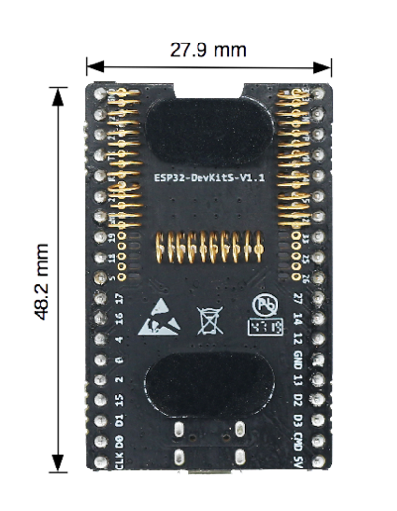
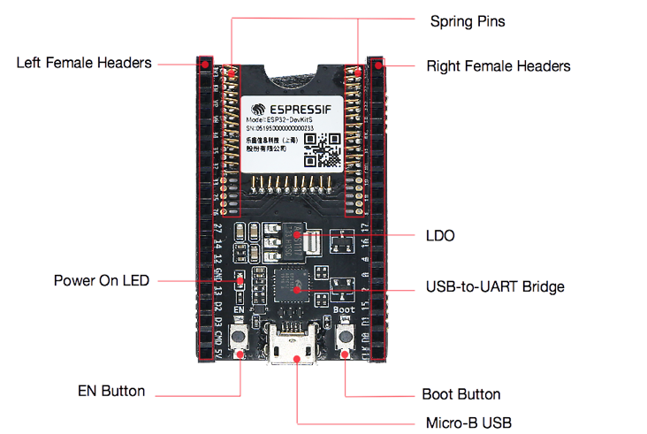
The ESP32 DevKit serves as the primary embedded controller of our system. It operates at 80 - 240 MHz, provides integrated Wi-Fi, multiple PWM channels, ADC inputs, and sufficient computational capability to execute real-time RSSI acquisition, motor control, and lightweight reinforcement learning algorithms. The firmware is developed using the Arduino IDE for rapid prototyping and deployment.

Figure 3-1: ESP32 Development Board Front and Back View

(source: Espressif Systems, ESP32 Documentation.)

3.1.2 Directional Antenna
A 2.4 GHz PCB directional panel antenna with typical gain 10 - 12 dBi is selected. The antenna operates in the 2.35 - 2.55 GHz ISM band, providing:
- Well-defined main radiation lobe
- Half-power beamwidth of approximately 30° - 60°
- Smooth RSSI variation with respect to orientation
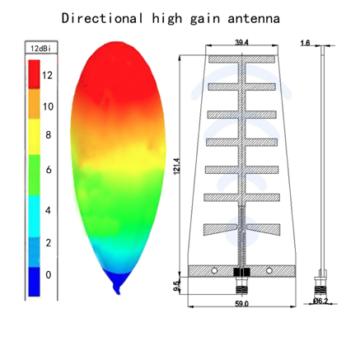
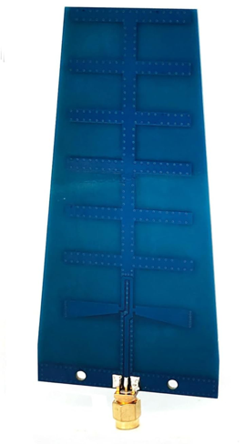
These characteristics are ideal for RSSI-driven control and reinforcement learning, as they produce predictable signal gradients and reduce learning instability. The antenna’s low mass (≈ 19 - 40 g) allows reliable mounting on small stepper actuators with minimal mechanical inertia.

Figure 3-2: High Gain 2.4 GHz Directional Antenna (PCB Panel Type)

3.1.3 RF Interfacing
The antenna is connected to the receiver using short RG174 coaxial cable with SMA connectors to minimize insertion loss. RSSI measurements are initially obtained directly from the ESP32’s integrated Wi-Fi system. Values are recorded per packet and averaged over a short window to reduce noise. Packet-level measurements are inherently noisy, which may cause minor stepper motor jitter and occasional confusion for the RL agent. This approach prioritizes low-cost hardware without external RF modules. If RSSI noise from the ESP32 proves too disruptive, a low-cost external module such as the nRF24L01 may be used to obtain more stable measurements, at the expense of slightly increased system complexity.

3.1.4 Motors
A stepper-motor-based actuation mechanism is employed to mechanically rotate the directional antenna and implement real-time orientation control as commanded by the alignment algorithm. A stepper motor is selected rather than a conventional servo motor to enable full 360° azimuthal coverage and provide deterministic angular positioning, which is required for repeatable RSSI-based alignment experiments.

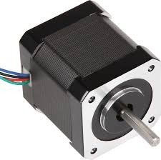
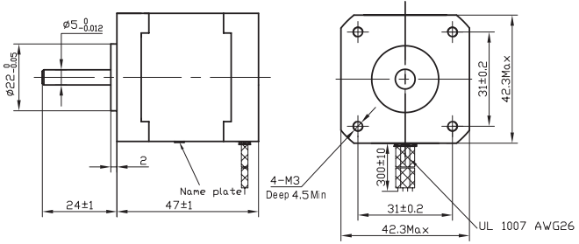

Figure 3-3: (a) NEMA 17 Stepper Motor (b) Motor Mechanical Layout
(source: https://www.ic-components.com/)
Stepper motors allow for discrete and repeatable angular steps (1.8° per full step for a standard NEMA 17 motor), which is adequate given the beamwidth of the 12 dBi directional antenna used in this work. Unlike standard positional servo motors, which are mechanically limited to about 180° of rotation, the stepper-based solution allows for continuous rotation over the full azimuth range, eliminating blind zones and ensuring a continuous and physically consistent relationship between antenna orientation and received signal strength.

3.1.5 Stepper Motor Driver Setup
The ESP32 is incapable of powering the stepper on its own so we will need a motor driver. The motor will be actuated by an A4988 Stepper Motor Driver. It supports current limiting and micro-stepping, making the motor move smoothly and precisely.
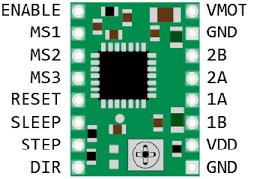
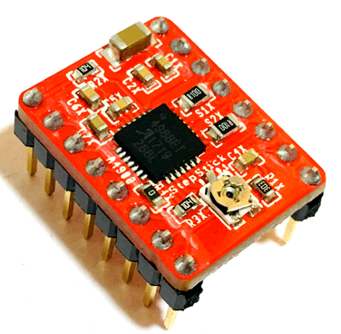

Figure 3-4: A4988 Stepper motor driver module and its pinout diagram
(source: components101 and aranacorp)
An AS5048 magnetic absolute rotary encoder can be optionally integrated to provide direct angle feedback for applications requiring higher angular accuracy or improved robustness. In the scope of this project, however, homing-based angle referencing combined with step counting should be sufficient.

3.1.6 Power Supply and Measurement
A regulated power supply is used to supply stable voltage to the microcontroller and motor driver. In this system, a dual-rail power configuration is adopted to keep logic and actuation loads isolated from each other and to prevent motor-induced voltage fluctuations from interfering with MCU operation.
Component | Voltage | Current
ESP32 | 5 V (regulated) | ≤ 500 mA
NEMA 17 stepper motor | 12 V | ≤ 1.2 A (per phase)

Table 2: Component Power Usage

A regulated 12 V / 3 A supply is provided for the stepper motor (for bench-top testing), together with a separate 5 V regulator for the ESP32. For the case of mobile operation, a 3S LiPo battery at 11.1 V supplies the stepper motor directly, while a buck regulator provides the microcontroller with a stable 5 V rail. Optional current sensing circuitry can be included for power consumption monitoring; however, energy efficiency is beyond the scope of the work. This configuration of supply provides steady operation during motor actuation without voltage sag or spurious resets to the microcontroller.

3.2 Software Tools
The following software tools are required for system development, training, deployment, and evaluation:
Arduino IDE is an integrated development environment used for programming and uploading firmware to microcontrollers. In this project, it serves as the primary platform for developing the ESP32 software, including routines for stepper motor control, RSSI measurement, and implementing the real-time antenna alignment logic. Its intuitive interface and built-in compiler make it suitable for embedded system development.
ESP32 Arduino Core provides the necessary hardware abstraction layer and low-level driver support for the ESP32. It allows easy access to peripherals such as GPIOs, ADCs, PWM, and Wi-Fi, enabling seamless control of the stepper motor, reading RSSI values, and managing communication without writing complex low-level code.
PyTorch is an open-source machine learning library that supports implementing reinforcement learning algorithms such as Q-Learning. In this project, PyTorch is used to simulate and test alignment strategies in a virtual environment before deploying them on the ESP32, helping to evaluate convergence, robustness, and performance of different algorithms efficiently.
Serial Monitor and Serial Plotter, tools integrated into Arduino IDE, can be used for real-time visualization of data during experiments. They allow monitoring of RSSI values, stepper motor positions, and overall system diagnostics, providing immediate feedback for debugging and validating the behavior of the implemented algorithms.
MATLAB and Python, along with libraries like NumPy and Matplotlib, are employed for data processing, analysis, and visualization. These tools help in plotting RSSI variations, evaluating alignment performance, and generating convergence curves, facilitating quantitative comparison between RL-based strategies and baseline methods.
Simulink, a graphical modelling environment within MATLAB, can be used as an alternative for system simulation. It allows modelling the antenna, stepper motor, and alignment algorithm in a block-diagram format, making it easier to test system dynamics and algorithmic behaviour before moving to the hardware implementation stage.
In addition to the core development and simulation tools, several auxiliary software tools will be used to support project management, documentation, and version control. LaTeX (Overleaf) will be used for writing the project report, formatting figures, tables, and equations professionally. Git and GitHub will provide version control for tracking code changes, managing branches, and enabling collaboration. Trello or similar project management tools will be employed to organize tasks, track progress, and maintain timelines. These tools complement the hardware and algorithm development environment by ensuring reproducibility, structured documentation, and efficient project workflow.

4. METHODOLOGY
The system proposed is a closed-loop control system which provides optimal physical positioning of a directional antenna using the RSSI values from the remote transmitter. The approach involves the integration of hardware components, the processing of the information, and the design of the alignment algorithm.

4.1 System Block Diagram and Architecture

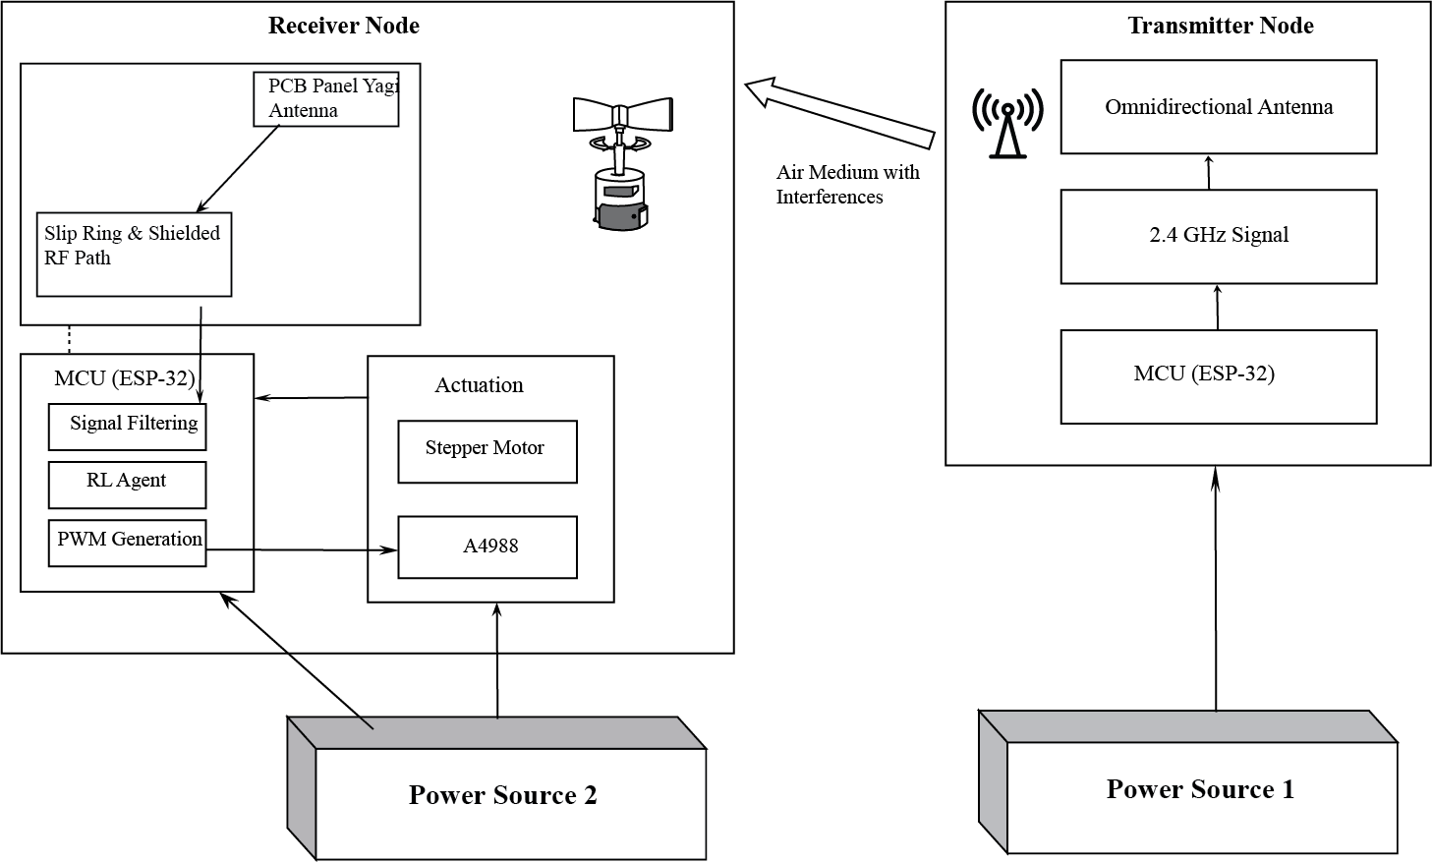
Figure 4-1: System Block Diagram
The hardware framework is centred around the ESP32 microcontroller, selected for its integrated WiFi stack and high-speed processing capabilities. The system uses a PCB-Panel type directional antenna. To achieve mechanical rotation, a NEMA 17 stepper motor is interfaced with the ESP32 via an A4988 motor driver. This configuration allows for a step resolution of 1.8° (typical NEMA 17 stepper motor full step), providing the granularity required to detect peak signal lobes. Power management is handled by a regulated DC supply to ensure that the high current draw of the motor does not interfere with the sensitive RF measurements of the receiver node.
The system consists of a transmitter node and an autonomous receiver node equipped with a mechanically steerable directional antenna. The transmitter continuously emits signals within a defined frequency band, while the receiver measures the received RSSI to determine signal quality. The RSSI data is processed by a microcontroller (ESP32), which runs a lightweight reinforcement learning (RL) algorithm to decide the optimal antenna orientation. Based on the algorithm’s output, stepper motors adjust the antenna direction in real time, ensuring alignment with the transmitter.
The architecture supports both baseline methods (full angular scan and RSSI-based hill-climbing) and RL based adaptive control, allowing a comparative study of convergence time, alignment accuracy, and link stability. The system is designed for continuous operation under dynamic conditions, including minor environmental changes, interference, and gradual mechanical drift, while maintaining low computational and power overhead.

4.2 Source and Receiver Configuration
To ensure a controlled and reproducible experimental setup, the wireless link will be implemented using two ESP32-based nodes operating in the 2.4 GHz ISM band.

4.2.1 Transmitter (Source Node)
The transmitter consists of a fixed ESP32 development board equipped with an omnidirectional antenna. It continuously broadcasts packets at a constant transmit power and predefined packet rate. The source node’s position is fixed throughout the experiment to ensure that variations in received signal strength at the receiver are caused primarily by changes in antenna orientation, rather than distance or mobility. The ESP32 firmware handles periodic packet transmission and includes basic logging for packet timing and sequence numbers to aid in analysis.

4.2.2 Receiver (Directional Antenna Node)
The receiver node comprises an ESP32 connected to a high-gain directional antenna mounted on a stepper motor. The motor enables controlled rotation in the azimuth plane to scan or align the antenna with the source. At each angular orientation, the ESP32 measures the RSSI of incoming packets, and optionally computes effective throughput or packet loss statistics. Multiple measurements are taken at each orientation and averaged to mitigate short-term fading and measurement noise. The receiver node also implements the alignment algorithm, updating antenna orientation in real time based on measured link quality.

4.3 Baseline Methods
To objectively assess the performance of the proposed reinforcement learning based antenna alignment strategy, it is compared against several conventional antenna alignment methods commonly employed in practical wireless systems. These baseline methods represent increasing levels of complexity and adaptivity and provide meaningful reference points for evaluating alignment accuracy, responsiveness, robustness to noise, and energy efficiency.

4.3.1 Fixed Antenna Orientation
In this baseline method, the receiver’s directional antenna is maintained at a constant orientation throughout the communication session. The initial antenna angle is either chosen arbitrarily or set during system initialization based on prior manual alignment.
This approach serves as a lower-bound reference, representing systems with no adaptive capability. Any improvement achieved by adaptive or intelligent alignment strategies can be directly quantified relative to this baseline.

4.3.2 Exhaustive Angular Scanning
In exhaustive angular scanning, the receiver systematically rotates the antenna across its entire angular range using predefined step sizes (e.g., 2° - 5°). At each orientation, the RSSI is measured and recorded. After completing a full scan, the antenna is positioned at the angle corresponding to the maximum observed RSSI.
This method approximates an optimal alignment under static conditions and is therefore treated as a performance upper bound in controlled environments. Exhaustive scanning is included to benchmark the maximum achievable RSSI under idealized conditions, against which the efficiency of the RL-based method can be compared.

4.3.3 RSSI-Based Hill-Climbing
RSSI-based hill-climbing is a heuristic, feedback-driven approach in which the antenna orientation is incrementally adjusted based on local RSSI measurements. At each step, the antenna is rotated slightly in one direction; if the RSSI increases, the motion continues in that direction, otherwise the direction is reversed.
This method represents a commonly used lightweight adaptive strategy in low-complexity antenna alignment systems. This baseline provides a strong comparison point against the proposed RL approach, particularly in evaluating robustness to noise and adaptability in dynamic environments.

4.4 Control Flow

4.4.1 Received Signal Strength Indicator (RSSI)
RSSI is a hardware-reported measure provided by the device radio subsystem that represents the received signal power of incoming packets, expressed in dBm. While RSSI does not directly represent link quality in a strict information-theoretic sense, it provides a low-overhead and readily available metric that correlates with antenna orientation for a fixed transmitter and channel configuration.
RSSI measurements are inherently volatile due to multipath fading, interference, and short-term channel fluctuations. To prevent the control mechanism from reacting to instantaneous noise, a lightweight digital signal processing layer is applied. The ESP32 samples RSSI values at a rate of 5 - 20 Hz, and a moving average filter is used to smooth short-term variations. The filtered RSSI value serves as a stabilized input to the control logic, reducing unnecessary motor actuation caused by transient signal dips. RSSI samples are averaged over a short sliding window to reduce noise before being fed to the control or RL algorithm, balancing responsiveness with measurement stability.
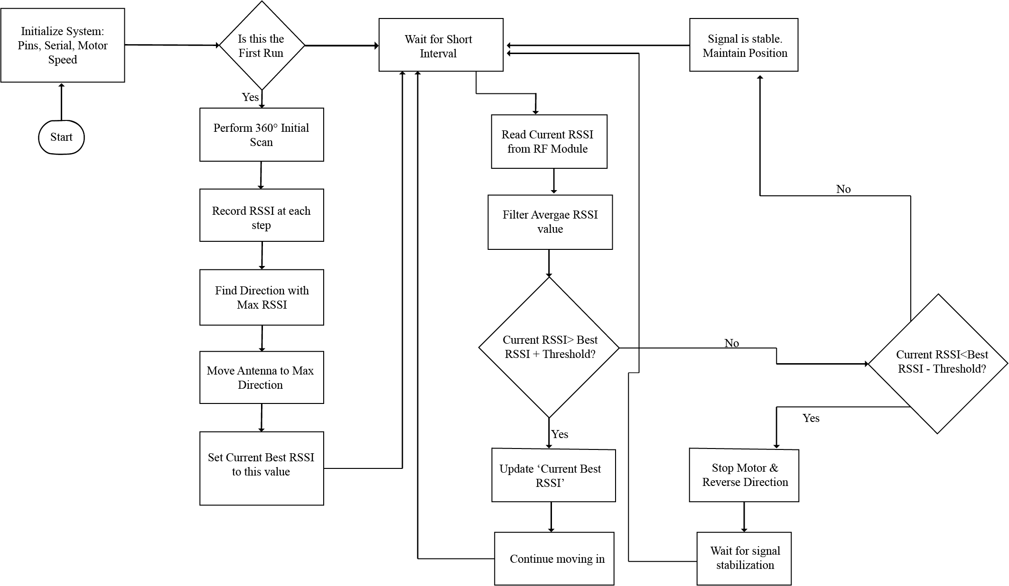
Figure 4-2: Logical Control Flow of Antenna Alignment
The control loop begins by initializing the ESP32 and centring the antenna. In each iteration, the system measures current RSSI and throughput values. A delay of about 200ms will be implemented between motor movement and RSSI sampling to allow for mechanical dampening, ensuring the ADC readings were not skewed by back-EMF or physical jitter. Depending on the operating mode, the data is either transmitted to a host system for analysis or processed locally by a control algorithm.
A full 360° angular scan is performed only during initial system calibration to identify approximate peak RSSI orientation. During normal operation, the RL agent adjusts the antenna incrementally; periodic full scans are not performed to avoid unnecessary energy consumption and mechanical wear.

4.5 Experience Collection and State Preparation for Reinforcement Learning
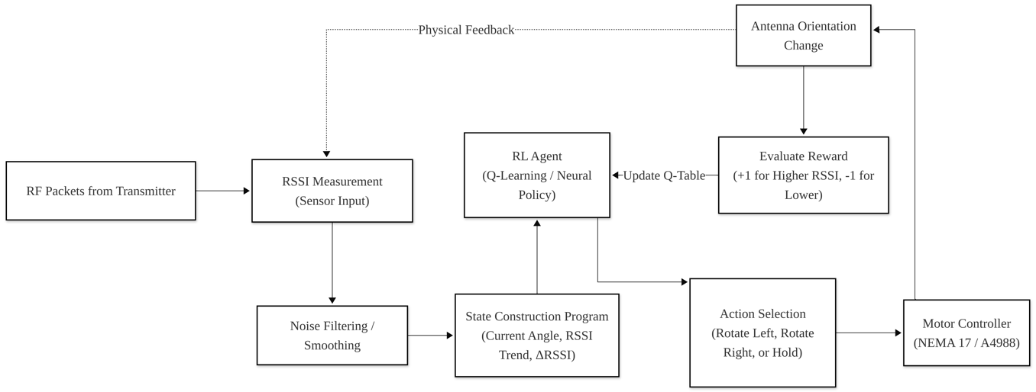

Figure 4-3: RL Experience Collection and State Preparation Pipeline

4.5.1 Data Acquisition
The receiver node continuously measures the Received Signal Strength Indicator (RSSI) from incoming transmitter signals at predefined sampling intervals synchronized with antenna motion. Each measurement corresponds to a specific antenna orientation controlled by a stepper motor. Optionally, additional link-quality metrics such as packet success rate or throughput may be recorded to enrich the system’s state representation.
- Sampling rate: 5 - 20 Hz, selected relative to actuator speed and expected channel dynamics.
- Filtering: Short sliding-window median or exponential moving average to reduce impulsive noise. Report filtered and raw RSSI for transparency.
- Timestamping & synchronization: Each sample includes MCU timestamp to correlate movement and reception.
Each measurement instance includes current RSSI value, Antenna orientation (stepper angle) and Timestamp. These measurements are used directly by the reinforcement learning agent during online operation.

4.5.2 Experience Logging and Storage
- During system operation, interaction data generated by the RL agent is optionally logged either locally or transmitted to a host computer for offline analysis, visualization, and performance evaluation.
- A sliding window of recent RSSI measurements is maintained on-device to capture short-term signal trends and mitigate the effects of instantaneous fluctuations.

4.5.3 State Representation and Feature Preparation
The RL agent operates on a compact, low-dimensional state representation derived from recent RSSI observations and antenna orientation. The state vector includes: Current antenna orientation, Recent RSSI trend over a sliding window and Rate of change of RSSI (ΔRSSI). Optionally, throughput or packet delivery metrics may be incorporated.
RSSI values are normalized to a fixed range (e.g., 0 - 1) to improve numerical stability and learning convergence.

4.5.4 Noise Mitigation and Signal Smoothing
RSSI measurements are inherently noisy due to multipath propagation, fading, and environmental interference. To reduce the impact of transient fluctuations, lightweight signal smoothing techniques such as moving average or exponential smoothing are applied prior to state construction. These techniques improve robustness while maintaining low computational overhead.

4.5.5 RL Experience Tuple Structure
Each interaction between the agent and the environment generates an experience tuple of the form:
- State (sₜ): Current antenna orientation and recent RSSI trend
- Action (aₜ): Discrete antenna movement (e.g., rotate left, rotate right, hold position)
- Reward (rₜ): Change in RSSI or link quality following the action
- Next State (sₜ₊₁): Updated state after antenna adjustment
These experience tuples are used by the RL algorithm to iteratively improve the antenna alignment policy during operation.

4.6 Reinforcement Learning Model Design

4.6.1 Reinforcement Learning (RL)
RL is a learning paradigm concerned with how an autonomous agent can learn to make sequential decisions through interaction with an environment in order to maximize a cumulative reward. Unlike supervised learning, where correct input-output pairs are provided, RL relies on evaluative feedback in the form of scalar rewards, which indicate the desirability of the agent’s actions rather than prescribing optimal behaviour directly. This framework is particularly suited to control and optimization problems where explicit models of the environment are unavailable or impractical to obtain [19].
In the reinforcement learning formulation, the problem is commonly modelled as a Markov Decision Process (MDP), defined by a set of states, a set of actions, a reward function, and state transition dynamics. At each time step, the agent observes the current state of the environment, selects an action according to a policy, receives a reward, and transitions to a new state. Over time, the agent improves its policy by balancing exploration of unknown actions and exploitation of actions known to yield higher rewards [19].
Model-free reinforcement learning methods, such as Q-Learning, estimate the expected long-term return associated with state–action pairs without requiring an explicit model of the environment. These methods are computationally lightweight and well suited to embedded systems with limited processing and memory resources. By learning directly from observed rewards, model-free RL can adapt to uncertain, noisy, and dynamically changing environments, making it applicable to real-time control problems such as antenna alignment based on received signal strength measurements.

4.6.2 Model Design
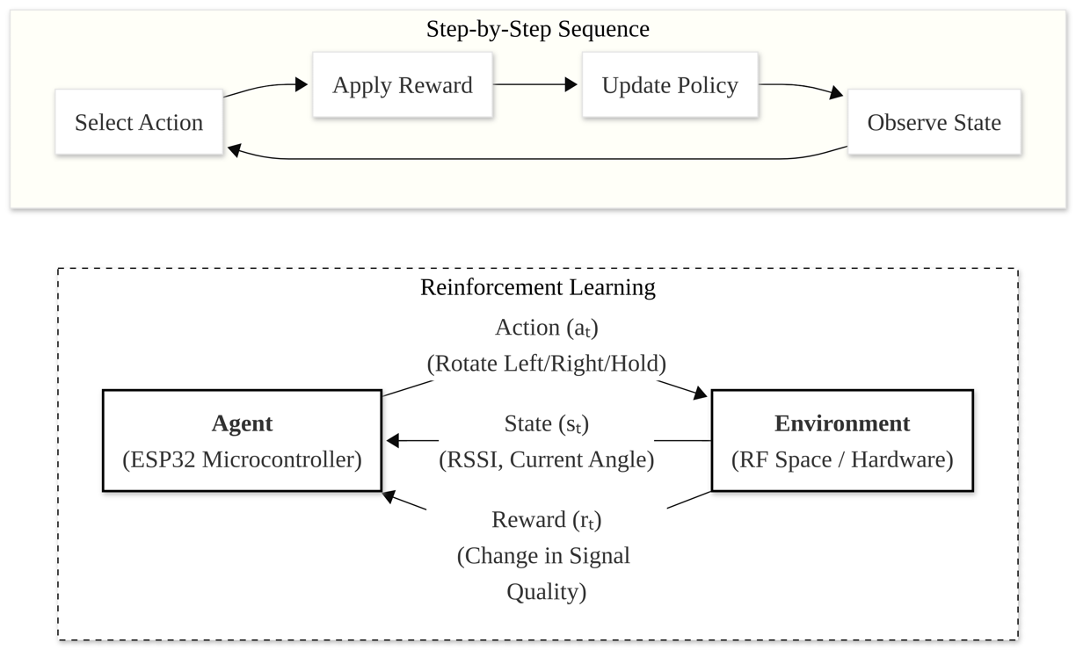
The reinforcement learning (RL) model constitutes the core decision making component of the proposed autonomous antenna alignment system. Its purpose is to enable the receiver node to adaptively adjust the orientation of a mechanically steerable directional antenna in order to maximize received signal strength (RSSI) under varying wireless channel conditions.
Figure 4-4: Basic Reinforcement Learning Model
The RL agent operates using low dimensional state information derived from RSSI measurements and antenna orientation. Learning and decision-making are performed online, directly on the embedded platform (ESP32), allowing the system to continuously adapt without reliance on external computation or prior training datasets. Offline experimentation and parameter tuning may be conducted on a PC for analysis and validation; however, the final learning mechanism is designed to be lightweight and executable on resource constrained hardware.

4.6.3 RL Algorithm Selection
The choice of reinforcement learning algorithm is guided by the need for simplicity, stability, and low computational overhead. Given the discrete nature of antenna motion and the limited state dimensionality, tabular Q-learning is selected as the primary algorithm.
Tabular Q-learning is well-suited for this application because:
- It supports discrete state and action spaces
- It requires minimal memory and computational resources
- It can be implemented using simple arithmetic operations
- It is robust for stationary or mildly dynamic environments
The algorithm learns a state action value function Q(s,a), which estimates the expected long term reward of taking action a in state s.

4.6.4 State Space
The state space represents the information available to the RL agent at each decision step. To ensure feasibility on embedded hardware, the state space is kept small and discrete. Each state consists of:
- Antenna orientation: Discretized angular position of the directional antenna (e.g., 0° - 360° divided into fixed steps)
- RSSI trend information: Derived from a sliding window of recent RSSI measurements, such as: Current RSSI value, Rate of change of RSSI (increasing, stable, or decreasing)
The resulting state vector captures both the current antenna direction and short-term signal behaviour, enabling the agent to make informed alignment decisions without requiring complex channel estimation.
The RSSI trend is classified using the following thresholds:
- Increasing: $∆RSSI> +1 dB$
- Stable: $\left|∆RSSI\right| ≤1 dB$
- Decreasing: $∆RSSI < -1 dB$
where ΔRSSI is computed over a short sliding window of recent RSSI samples.
Q-Table Size and Memory Footprint
Let the antenna orientation be discretized into $N_{θ}$​ angular positions and the RSSI trend take $N_{r}$​ discrete values. With $N_{a}$​ possible actions, the total Q-table size is
$$\left|Q\right|=N_{θ}×N_{r}×N_{a}$$
For the current design, $N_{θ}=360°$(10° resolution over 360°), $N_{r}=3$ (increasing, stable, decreasing), and $N_{a}=3$actions, resulting in
$\left|Q\right|=36×3×3=324$ Q-values
Assuming each Q-value is stored as a 32-bit floating-point number (4 bytes), the total memory requirement is approximately 1.3 kB, which is negligible relative to the available RAM on the ESP32 (i.e. 520kB), confirming suitability for embedded implementation.

4.6.5 Action Space
The action space defines the set of possible antenna movements available to the RL agent. Actions are discrete and correspond to simple mechanical adjustments of the antenna. The defined actions include:
- Rotate antenna by a fixed step in the clockwise direction
- Rotate antenna by a fixed step in the counter clockwise direction
- Maintain current antenna orientation
The angular step size is selected based on a trade-off between alignment precision and mechanical response time.

4.6.6 Reward Function Design
The reward function provides evaluative feedback to the reinforcement learning agent by quantifying the impact of each antenna movement on link quality. The primary objective is to maximize the received signal strength while simultaneously discouraging unnecessary mechanical motion that may lead to oscillatory behaviour, increased wear, or slow convergence.
The instantaneous reward at time step t is defined as:
$$r\left(t\right)= ∆RSSI\left(t\right)- γ\left|∆θ(t)\right|$$
where:
- $∆RSSI\left(t\right)$represents the change in received signal strength following the executed action, computed as the difference between the filtered RSSI measurements before and after antenna movement.
- $∆θ\left(t\right)$denotes the angular displacement commanded by the agent at time t.
- $γ$is a non-negative weighting factor that controls the trade-off between maximizing signal strength and minimizing mechanical actuation.
A positive reward is obtained when an action results in an improvement in RSSI, encouraging movements that align the antenna more closely with the transmitter. Conversely, actions that degrade RSSI yield negative rewards, guiding the agent away from suboptimal orientations. The motion penalty term discourages excessive or unnecessary antenna movements, promoting stable convergence and reducing oscillations around local maxima.
The parameter $γ$ is selected empirically to ensure that the reward remains dominated by RSSI improvements while still penalizing inefficient actuation. This formulation enables the agent to learn an alignment policy that balances communication performance with mechanical efficiency under real-time and embedded system constraints.

4.6.7 Learning and Exploration Strategy
To balance exploration and exploitation during antenna alignment, an ε-greedy action selection policy is employed. At each decision step, the agent selects a random action with probability ε to explore alternative antenna orientations, and selects the action with the highest estimated Q-value with probability $1 - ∈$. This approach enables initial exploration of the orientation space while progressively favouring actions that yield higher received signal strength.
The exploration rate ε is gradually reduced over time according to a predefined decay schedule, allowing the agent to transition from exploratory behaviour to more stable exploitation as sufficient experience is accumulated. A minimum exploration rate is maintained to allow limited adaptation to slow environmental changes, such as minor variations in the wireless channel. Q-values are updated online using the standard Q-learning update rule after each executed action and corresponding RSSI observation. This online update mechanism allows the agent to learn directly from real-time interaction with the environment without requiring offline training or stored datasets.
Due to multipath fading and environmental noise, the RSSI landscape may contain local maxima that can trap greedy alignment strategies. The ε-greedy exploration mechanism mitigates this risk by periodically forcing the agent to explore alternative antenna orientations, allowing it to escape suboptimal local peaks and discover globally better alignment configurations. As ε decays over time, the agent progressively stabilizes around high-performing orientations while retaining limited adaptability to slow environmental changes.

4.6.8 Online Training and Real-Time Operation
The reinforcement learning agent updates its Q-table incrementally during normal system operation. Each learning iteration is synchronized with antenna motion and RSSI sampling, ensuring that reward evaluation occurs only after the antenna has reached its commanded orientation and the received signal has stabilized. Each learning episode is limited to a fixed number of iterations (200 - 500 steps) to prevent indefinite exploration, after which the agent continues with a stabilized policy, allowing consistent performance evaluation.
Due to the discrete action space and low-dimensional state representation, the Q-table remains small $≈1.3 KB$, resulting in low computational and memory overhead. This makes real-time learning feasible on the ESP32 microcontroller without impacting system responsiveness. The learning process is designed for gradual adaptation rather than rapid convergence, making it suitable for static and mildly dynamic wireless environments where abrupt channel variations are limited.

4.7 Experimental Setup and Evaluation
This section describes the experimental conditions, evaluation metrics, and comparison protocol used to assess the performance of the proposed autonomous antenna alignment system.

4.7.1 Experimental Environment
Experiments are planned in both indoor and outdoor environments to evaluate system behaviour under diverse propagation conditions.
- Indoor environment: Laboratory or corridor environment containing walls, metallic objects, and reflective surfaces, resulting in multipath propagation and RSSI fluctuations.
- Outdoor environment: Open or semi-open area with a fixed transmitter and receiver separated by a distance determined through preliminary link budget analysis (typically ranging from 30 m to 300 m), representing line-of-sight or mildly obstructed communication scenarios.
The system will be evaluated under the following conditions:
- Random initial misalignment of the receiver antenna
- Static environment with no movement
- Mildly dynamic environment with occasional obstructions or disturbances
- Repeated alignment cycles to observe learning behaviour and convergence consistency

4.7.2 Evaluation Metrics
To enable quantitative and fair comparison between the proposed RL-based method and baseline approaches, the following evaluation metrics are employed.
Received Signal Strength Indicator (RSSI)
RSSI is the primary indicator of link quality and is recorded continuously throughout each experiment. Higher RSSI values correspond to improved antenna alignment and communication performance. To mitigate short-term noise, RSSI values are computed using averaged or filtered samples over a fixed observation window.
Alignment Accuracy ($A_{acc}$)
Alignment accuracy measures how closely the antenna orientation selected by the algorithm approaches the best observable orientation under the given propagation conditions. It is defined as:
$$A_{acc}=\left|θ_{alg}-θ_{opt}\right|$$
where:
- $θ_{alg}$​ is the antenna angle selected by the alignment algorithm
- $θ_{opt}$​ is the antenna angle that yields the maximum measured RSSI during an exhaustive angular scan
Lower values of ​ $A_{acc}$ indicate more accurate alignment.
Convergence Time $(T_{(conv)})$
Convergence time quantifies the responsiveness of the alignment algorithm. It is defined as the time required for the system to reach and maintain a stable antenna orientation such that:
$$\left|RSSI\left(t\right)-{RSSI}_{max}\right|≤ ∈dB, ∀t≥T_{conv}$$
where $∈$ is a predefined tolerance threshold
In this work, the tolerance threshold is set to ε = 2 dB, which represents a practical compromise between alignment precision and RSSI noise sensitivity.
Link Stability (S)
Link stability reflects the system’s ability to maintain alignment after convergence and is measured as the variance of RSSI over a fixed observation window following convergence:

$$S=Var\left(RSSI\left(t\right)\right), t∈\left[T_{conv}, T_{conv}+W\right]$$
Lower RSSI variance indicates greater stability and robustness to noise and environmental perturbations.

Mechanical Efficiency and Energy Proxy (E)
Direct energy measurement is not performed; instead, a proxy metric is used to reflect mechanical wear and operational efficiency:

$$E ≈k1.N_{moves}+k2.T_{active}$$
where:
- $N_{moves}$​ is the number of antenna motion commands
- $T_{active}$​ is the active processing time of the MCU
- k1, k2​ are proportional constants
Lower values of E indicate more efficient alignment behaviour with reduced mechanical actuation.

4.7.3 Experimental Protocol for Method Comparison
The proposed RL-based alignment method is compared against baseline strategies, including fixed-orientation alignment, exhaustive angular scanning, and RSSI-based hill-climbing. All methods are evaluated under identical environmental conditions using the following procedure:
- Initialize the antenna at a random misaligned orientation
- Activate the alignment algorithm
- Continuously record RSSI, antenna angle, and timestamps
- Introduce controlled disturbances (angular offsets or temporary obstructions)
- Measure recovery behaviour and post-convergence stability
- Repeat each experiment for $N≥20$trials to ensure statistical reliability

4.7.4 Statistical Analysis
For each evaluation metric $A_{acc}, T_{conv}, S, E$the mean and standard deviation are computed across trials. Performance of the RL-based approach is compared with baseline methods using paired statistical tests, such as paired t-tests or non-parametric equivalents where appropriate, to assess statistical significance.

5. EXPECTED OUTCOMES
At the completion of this project, the following outcomes are expected:

5.1 Functional Autonomous Alignment Prototype
A working prototype of a receiver-side autonomous directional antenna alignment system implemented on embedded hardware. The system will be capable of mechanically steering a directional antenna and adjusting its orientation in real time based on RSSI measurements obtained from the wireless link.

5.2 Improved Alignment Performance Compared to Baseline Methods
Experimental results demonstrating improved antenna alignment behaviour compared to fixed-orientation and conventional methods. Improvements are expected in terms of faster convergence to favourable antenna orientations, higher average RSSI levels, and improved link stability under static and mildly dynamic conditions.

5.3 Feasibility of RL on Resource Constrained Hardware
Successful implementation of a Q-Learning based decision mechanism operating within the computational, memory, and power constraints of a microcontroller platform (e.g., ESP32). This outcome will demonstrate that simple reinforcement-based control strategies can be executed in real time without reliance on high-end processors or advanced RF hardware.

5.4 Quantitative Performance Evaluation and Analysis
A comprehensive experimental evaluation of system performance, including measurements of convergence time, achieved RSSI gain, RSSI stability over time, and actuator activity (as a proxy for energy consumption). Results will be analysed for both baseline and learning-based approaches to highlight trade-offs and practical benefits.

5.5 Validated, Low-Cost, and Replicable Design
A documented system architecture and methodology that can be replicated or extended for low-cost point-to-point wireless links, IoT deployments using directional antennas, and educational or experimental platforms for studying adaptive RF control techniques on embedded systems.

6. PROJECT SCHEDULE

6.1 GANTT CHART
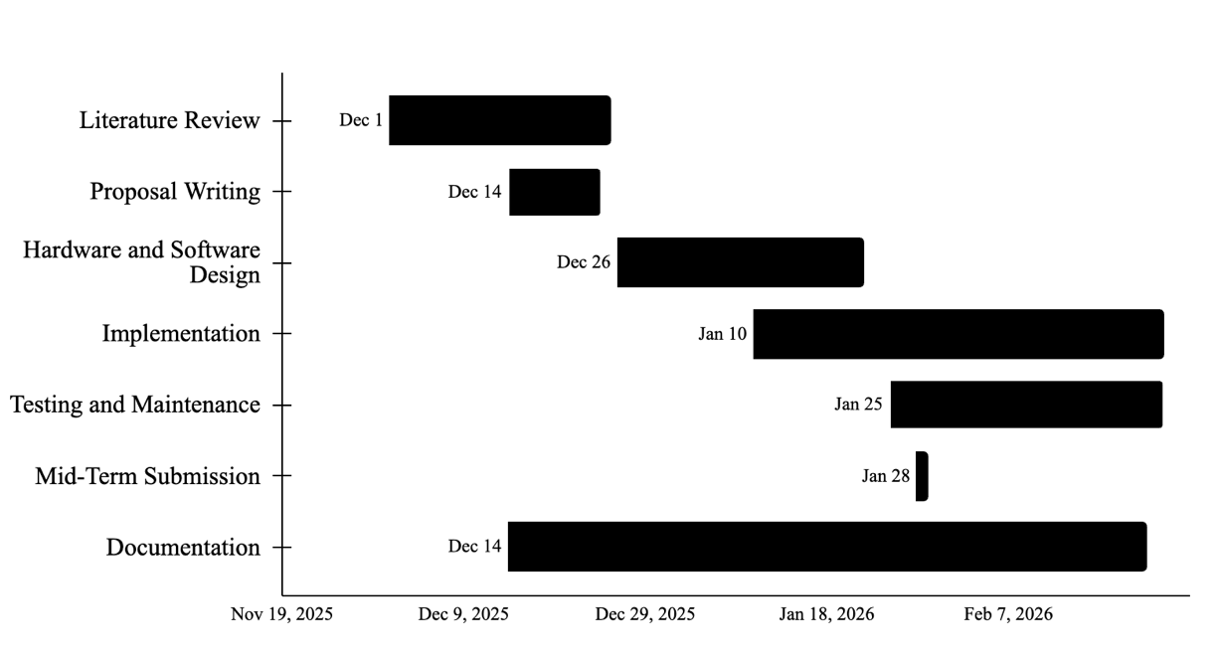

Figure 6-1: Project Predicted Timeline

7. BUDGET ESTIMATION
Item | Quantity | Estimated Cost (NRs.)
Microcontroller ESP32 DevKit | 2 | 2400 - 3500
NEMA 17 Stepper Motor | 1 | 1,500
A4988 Motor Driver | 1 | 350
100uF Capacitor | 5 | 100
18650 Li-Ion Battery (High Drain) | 3 | 1500
3S 18650 Battery Holder | 1 | 150
3S 20A BMS Board | 1 | 350
LM2596 Buck Converter | 1 | 600
2.4GHz Yagi Antenna | 1 | 700 - 2,500
Pigtail Cable (SMA) | 1 | 400
Logistics | - | 1000
Total Estimated Cost |  | 9000 – 12000 (approx.)

Table 3: Approximate Budget Estimation

8. FEASIBILITY ANALYSIS

8.1 Technical Feasibility
The proposed system is technically feasible using commercially available and well-supported components. The ESP32 microcontroller provides sufficient processing capability to acquire RSSI measurements, control stepper motors, and execute a lightweight tabular Q-learning algorithm in real time. The use of a mechanically steerable 2.4 GHz directional antenna avoids the complexity of phased arrays or beamforming hardware while still providing a clear RSSI gradient for alignment. The required angular resolution is well within the capabilities of a stepper motor, and the overall system does not rely on specialized RF instrumentation or complex signal processing, making implementation practical.

8.2 Computational Feasibility
The reinforcement learning approach is computationally feasible on the ESP32 platform. The use of tabular Q-learning with a small, discretized state and action space results in a very small memory footprint and low computational overhead. Q-table updates involve only basic arithmetic operations and are performed at a low control frequency, ensuring real-time operation without affecting system stability. The algorithm does not require offline training, large datasets, or floating-point intensive computation, making it suitable for resource-constrained embedded hardware.

8.3 Economic Feasibility
The project is economically feasible within a typical undergraduate project budget. All required hardware components, including the ESP32 boards, stepper motor, motor driver, power electronics, and directional antenna, are low-cost and readily available. The total estimated cost of NRs. 9,000 - 12,000 is reasonable and does not involve proprietary hardware or paid software licenses. The use of open-source development tools further reduces financial constraints.

8.4 Time Feasibility
The project is feasible within the allocated academic timeline. Hardware assembly and basic firmware development can be completed early in the project, followed by implementation of baseline alignment methods and reinforcement learning logic. The modular design allows incremental testing and debugging, reducing integration risk. The scope is intentionally limited to static and mildly dynamic environments, which avoids excessive experimentation time and supports timely completion.

8.5 Operational Feasibility
The system is operationally feasible in controlled indoor and outdoor environments. The experimental setup requires only a fixed transmitter and a steerable receiver, both of which can be deployed without complex infrastructure. RSSI-based feedback is directly obtainable from the ESP32 Wi-Fi interface, enabling autonomous operation without external sensors. While RSSI variability introduces noise, the use of filtering and repeated trials ensures stable operation and meaningful evaluation.

8.6 Academic Feasibility
From an academic perspective, the project is feasible and well-scoped. It addresses a clearly defined problem using established techniques and focuses on practical validation rather than theoretical novelty. The project enables quantitative comparison with baseline methods and demonstrates the applicability of reinforcement learning in embedded RF control, satisfying the requirements of an undergraduate engineering project.

References
[1] C. Beard and W. Stallings, Wireless Communication Networks and Systems.
Pearson, 2016.
[2] H. L. Hartnagel, R. Quay, U. L. Rohde, and M. Rudolph, Fundamentals of RF and Microwave Techniques and Technologies. Springer, 2023.
[3] Y. Zhang, X. Wang, and Y. Wang, “Research on automatic alignment technology of antennas in troposcatter communication vehicular stations,” Radio Communications Technology, vol. 3, pp. 39–40, 2009.
[4] L. Sheng, D. Yu, G. Li, and X. Ji, “Imitation human intelligence control-based antenna tracking system for vehicle,” Computer Measurement & Control, vol. 14, no. 2, pp. 212–213, 2006.
[5] D. Zhang, R. Sun, P. Li, and Z. Zhao, “Design of servo tracking system of microwave vehicle antenna,” Journal of Air Force Engineering University (Natural Science Edition), vol. 4, no. 3, pp. 47–49, 2003.
[6] X. Shen, Z. Qi, L. Wang, and G. Wang, “Research on direction of data conciliation antennas in location systems using time difference among multi-station,” Electronic Information Warfare Technology, vol. 23, no. 4, pp. 22–24, 2008.
[7] Cisco, Cisco Visual Networking Index: Global Mobile Data Traffic Forecast Update, 2017–2022, White Paper, Cisco Systems, San Jose, CA, USA, 2019.
[8] H. Yang, M. H. Herben, I. J. Akkermans, and P. F. Smulders, “Impact analysis of directional antennas and multiantenna beamformers on radio transmission,” IEEE Transactions on Vehicular Technology, vol. 57, no. 3, pp. 1695–1707, 2008.
[9] M. Giordani et al., “A literature survey on AI-aided beamforming and beam management for 5G and 6G systems,” IEEE Communications Surveys & Tutorials, 2020.
[10] S. Ahmed et al., “Comparative analysis of machine learning algorithms for antenna alignments,” IEEE Access, 2021.
[11] A. T. Koru, J. Chang, and Y. Wan, “RSSI-based distributed control to align directional antenna pairs for UAV communication,” IEEE/ASME Transactions on Mechatronics, 2024.
[12] L. Zhang et al., “Multi-agent reinforcement learning with common policy for antenna tilt optimization,” IEEE Transactions on Wireless Communications, 2022.
[13] F. Cuomo et al., “Self-orientation of directional antennas assisted by mobile robots for receiving the best wireless signal strength,” Ad Hoc Networks, 2016.
[14] Y. Wan et al., “Received signal strength indicator-based decentralized control for robust long-range aerial networking using directional antennas,” IEEE Transactions on Aerospace and Electronic Systems, 2018.
[15] S. Lee et al., “Learning-based beam alignment for uplink mmWave UAVs,” IEEE Transactions on Vehicular Technology, 2023.
[16] J. W. Smith et al., “SmartAntenna: Enhancing wireless range with autonomous orientation,” International Journal of Distributed Sensor Networks, 2019.
[17] Á. L. Makara, B. T. Csathó, A. Rácz, T. Borsos, L. Csurgai-Horváth, and B. P. Horváth, “Deep-Learning-Based Antenna Alignment Prediction for Mobile Indoor Communication,” Sensors, vol. 23, no. 7, p. 3375, 2023, doi: 10.3390/s23073375.
[18] J. Lee, H. Kim, and J. So, “Reinforcement Learning-Based Joint Beamwidth and Beam Alignment Interval Optimization in V2I Communications,” Sensors, vol. 24, no. 3, p. 837, 2024, doi: 10.3390/s24030837.
[19] R. S. Sutton and A. G. Barto, Reinforcement Learning: An Introduction, 2nd ed. Cambridge, MA, USA: MIT Press, 2018. ISBN 978-0262039246.

